**Ex. 7. PHP – Super Global variables**

**URK17CS127**

**Date:**

Design a **multi-page shopping cart** in PHP using super global variables (sessions, post or get). Use PHP sessions to store page wise form field values and validate form field values on each page using HTML5 form elements. At the end, collect values from all pages and display the summary page.

**Page1: Simple shopping cart**

Design a simple shopping cart as given below. Add a form with an action value of second.php and method value of ”post”. Code the form with auto complete active. This form contains both required and optional fields. Asterisk (*) before each field indicates required fields and other fields are optional. When user fills the fields and clicks on next button, it will redirect to second page.

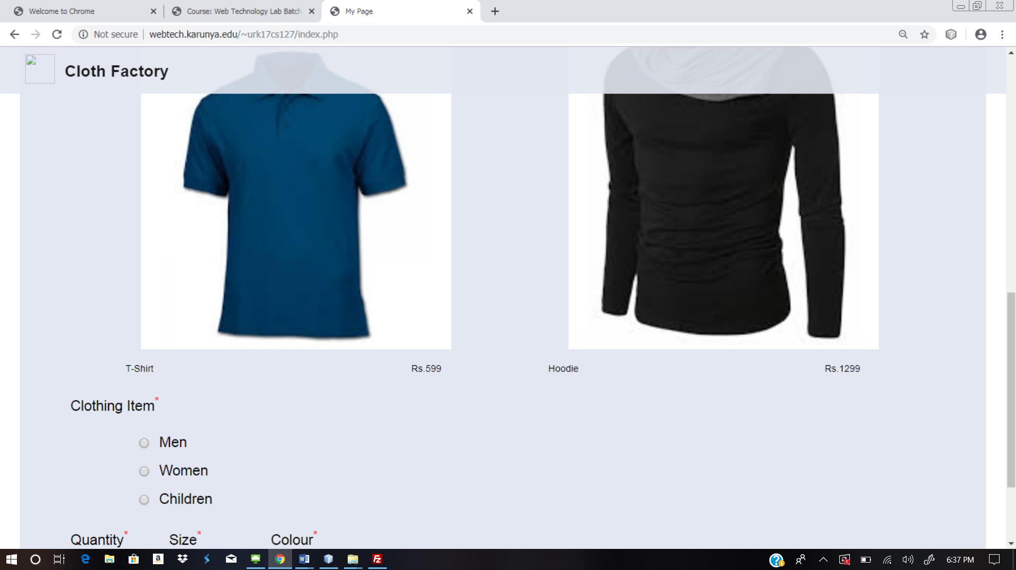

**Page 2: Shipping Information**

Set sessions for all information received from page1. Design a form to get shipping information from user. As user clicks the continue button, redirect the user to third page.

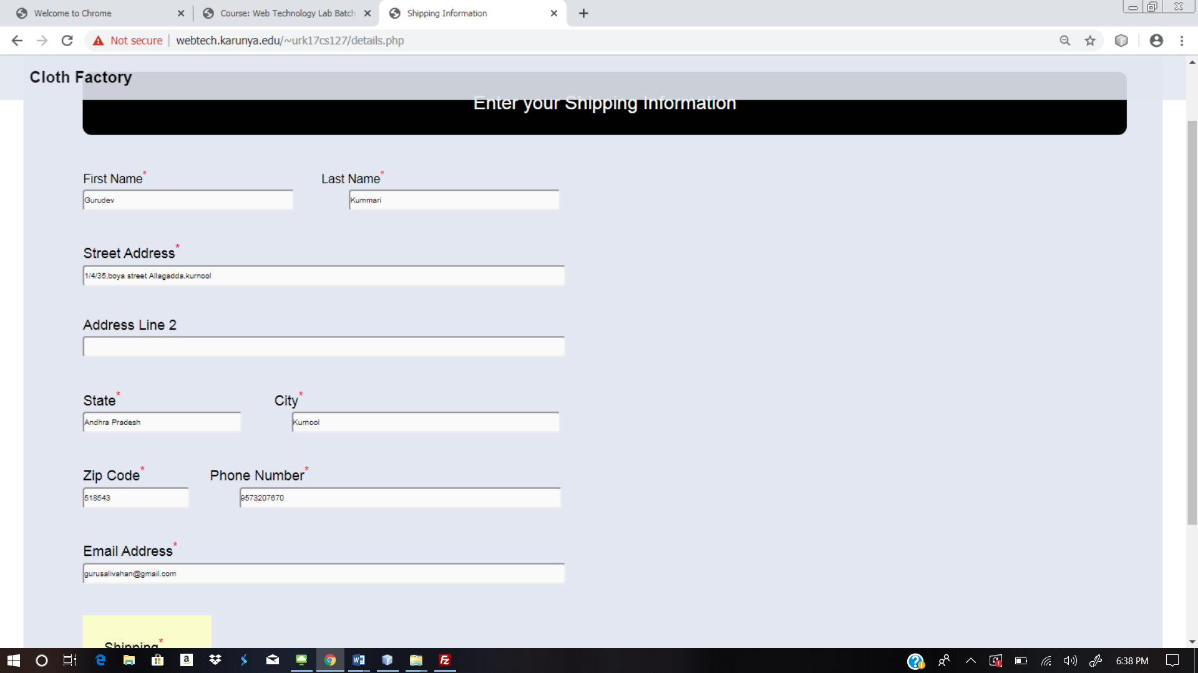

**Page 3: Delivery confirmation**

Generate a confirmation page with all information received from second page (user **$_POST[ ] or $_GET[ ]** array) and first page(Use **$_SESSION[ ]**). Display the order summary as given below.

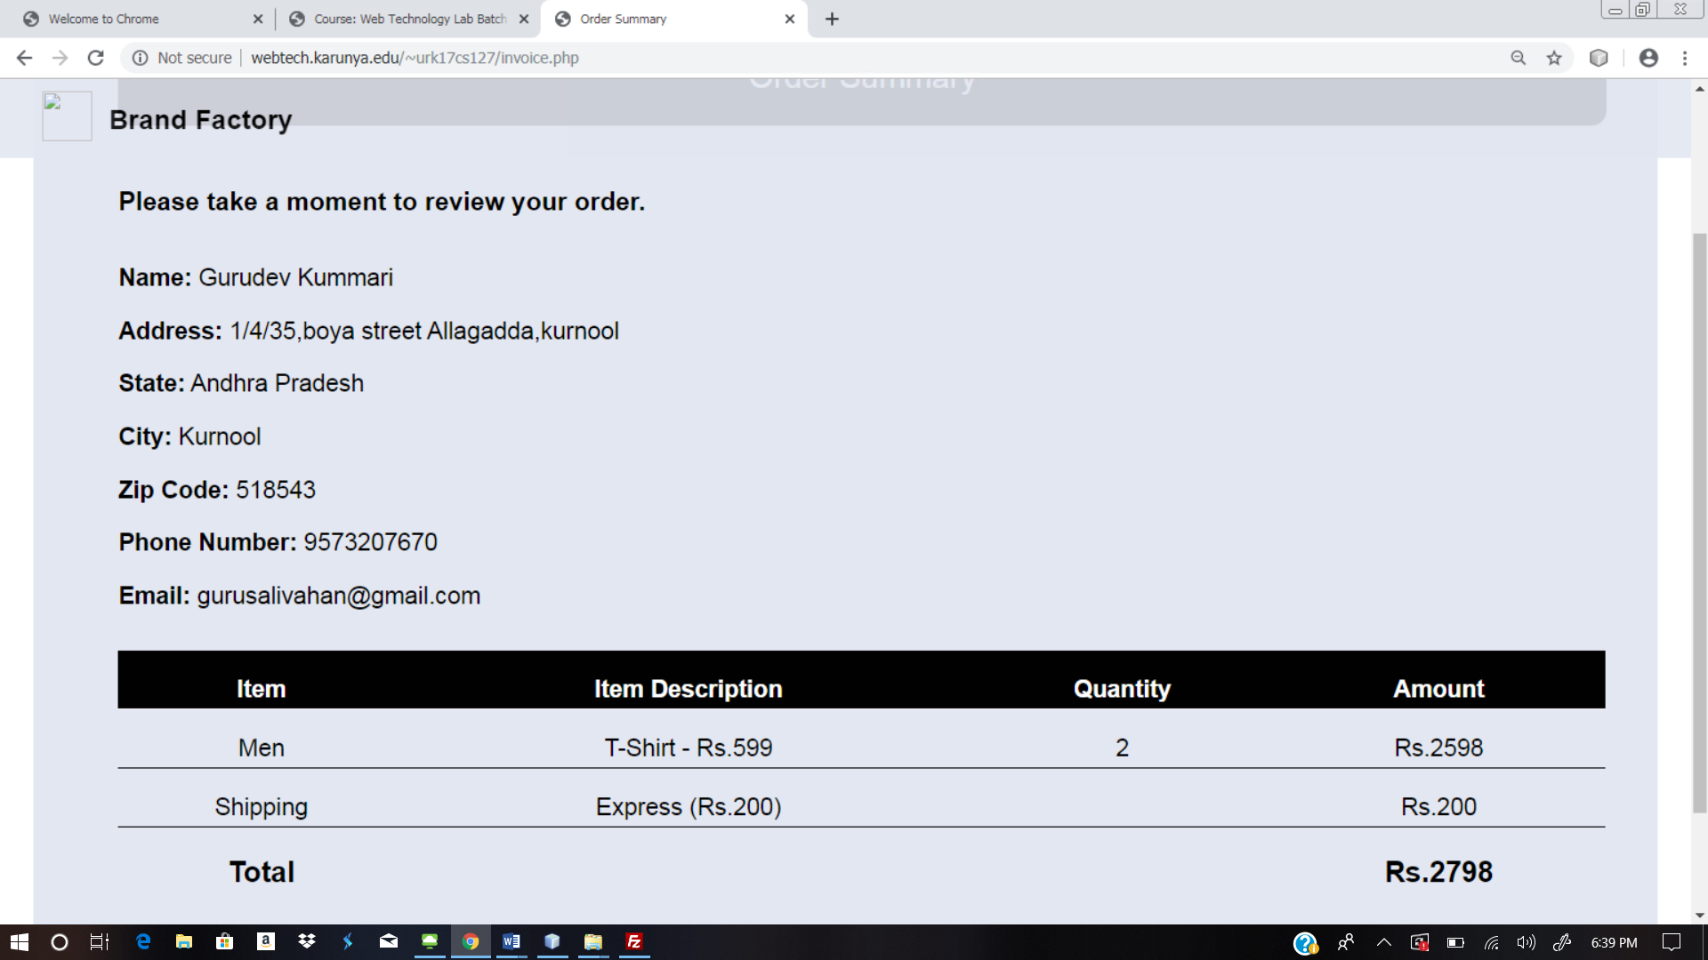

**Web site URL:** <http://urk17cs127.rf.gd/Exercise7/>

**You tube URL:** [**https://youtu.be/mpA8NRmHWcI**](https://youtu.be/mpA8NRmHWcI)

**RESULT:**

The above website created using the php connection using sessions and coockies and output is verified.